Elastic IP Address:

1. We want create a Instance to associate Elastic IP.

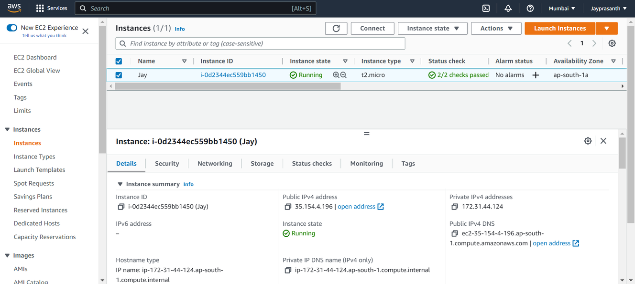

1. Then go to Elastic IP in left side column, then click Allocate Elastic IP address.

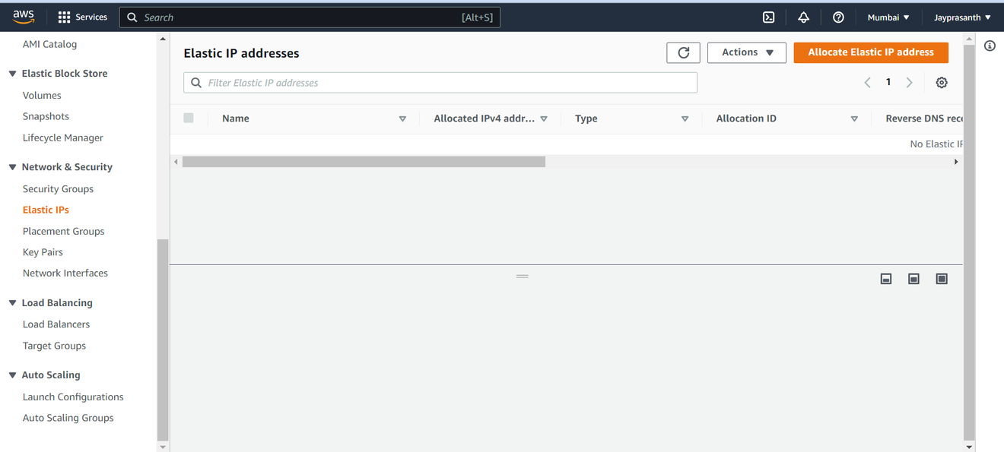

3.This Windows shows,

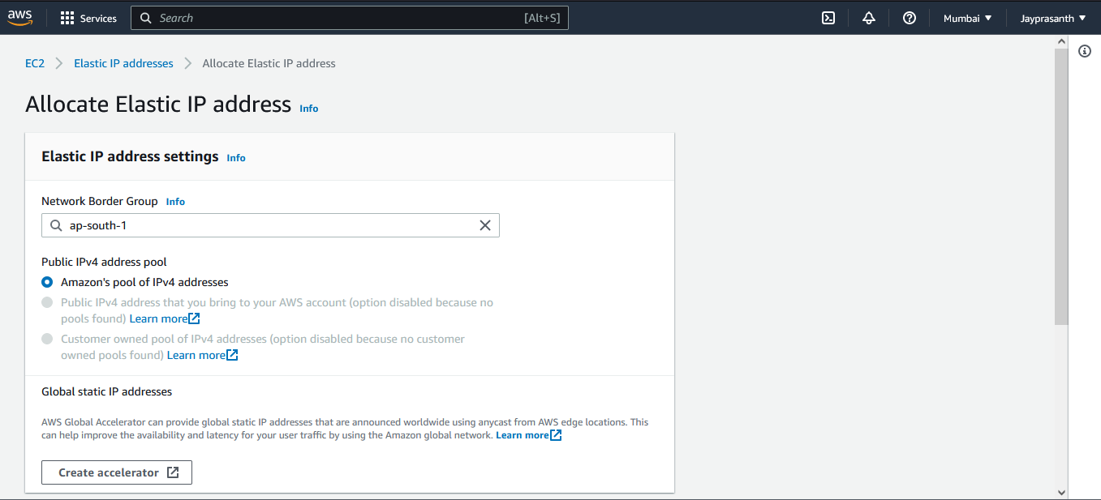

4.Click Allocate to create Ip

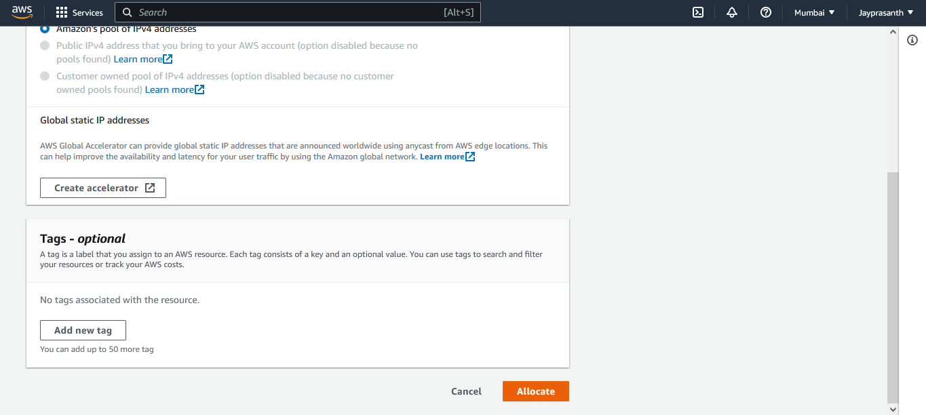

5.Elastic IP is allocated

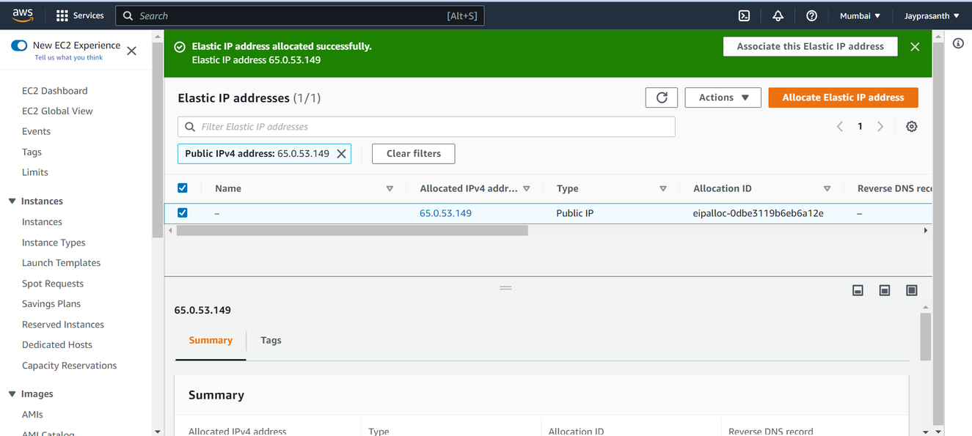

6.Then to associate with our instance, go to Actions -->Associate Elastic IP address

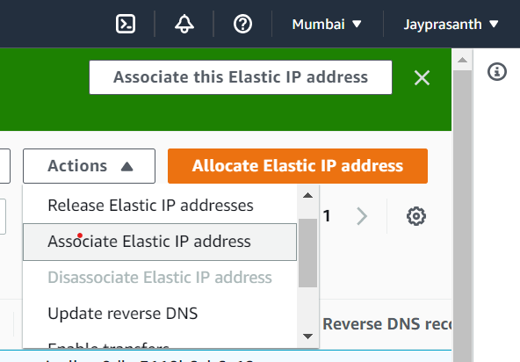

7.this window appears,

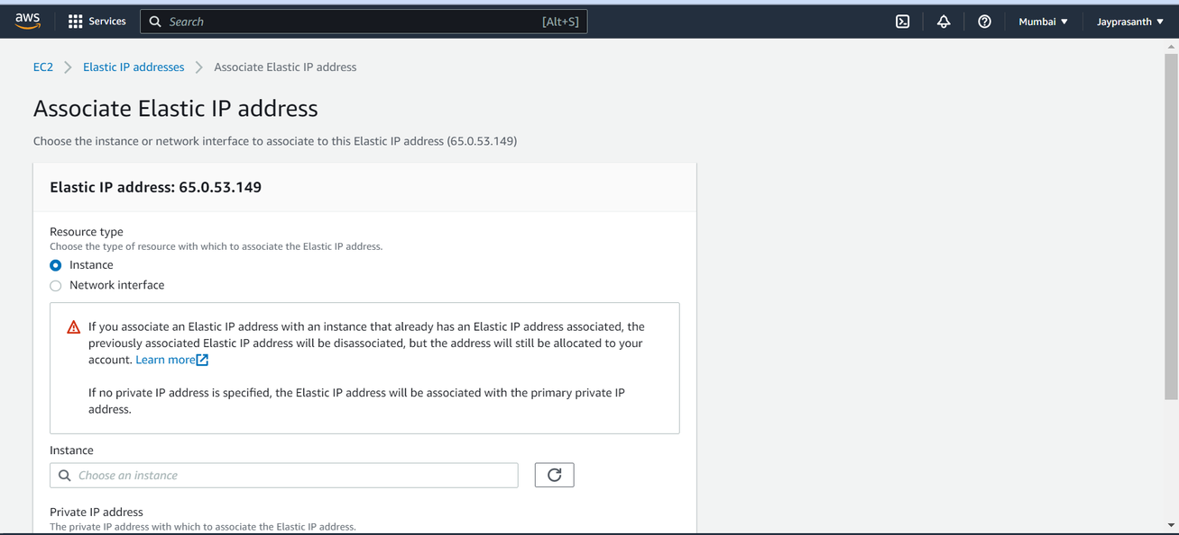

8. and then click instance and choose what instance we want and private is optional to click, then click associate

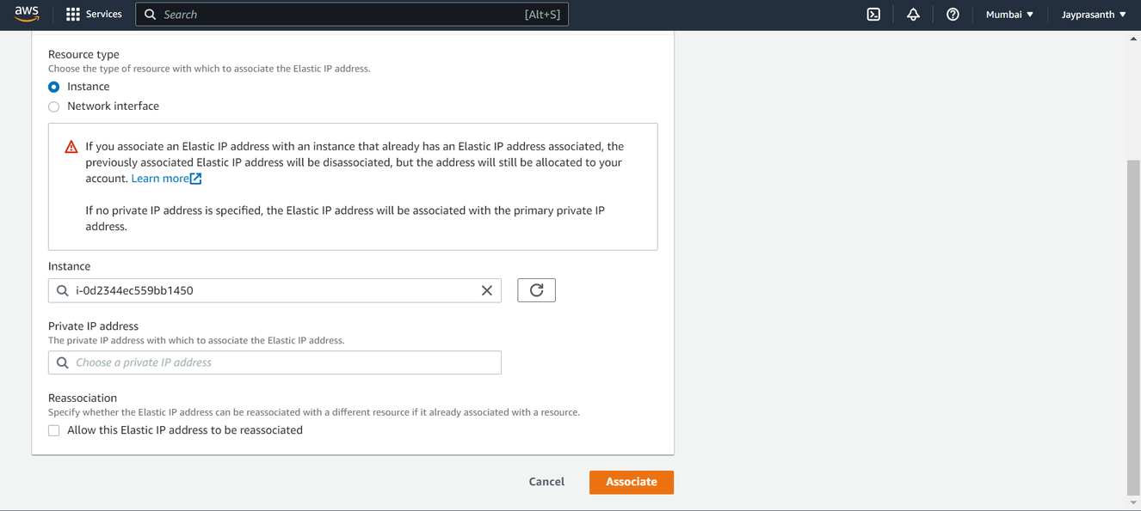

9.our elastic ip is successfully associated with our instance

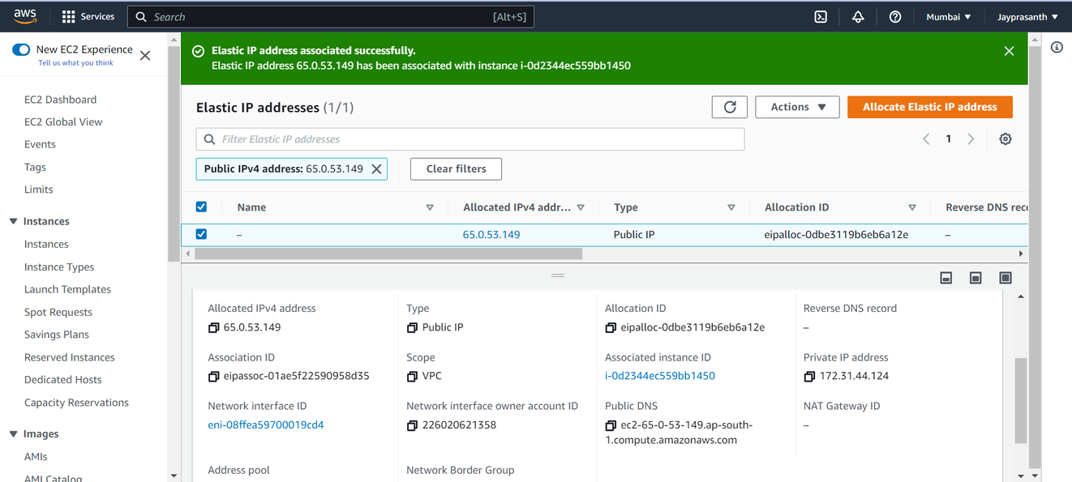

10.this shows the instance with elastic IP

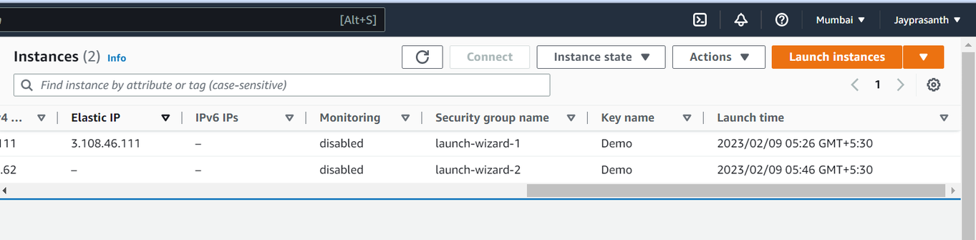

11.After finishing our work, we disassociate our elastic

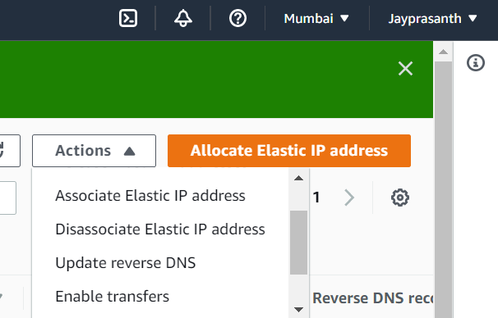

12.this window show, and click disassociate

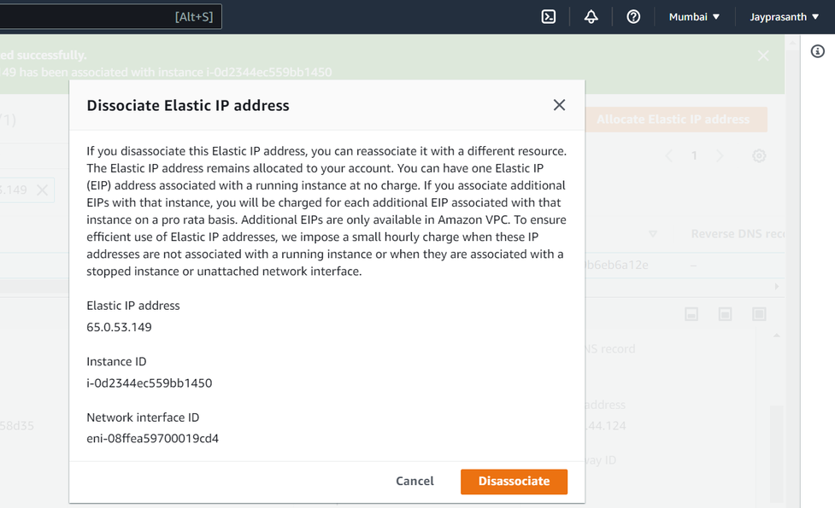

13.it successfully disassociate with instance

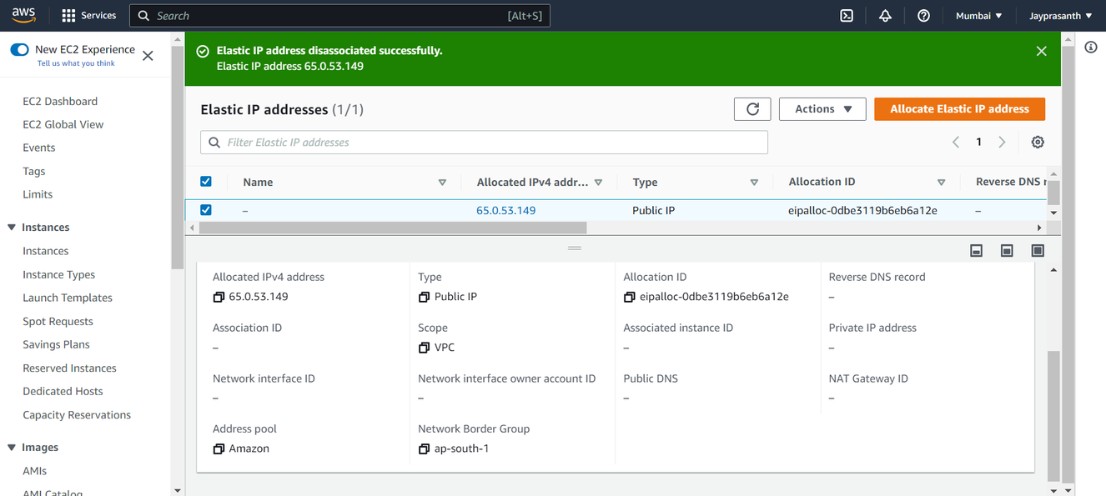

14. Then release our elastic IP

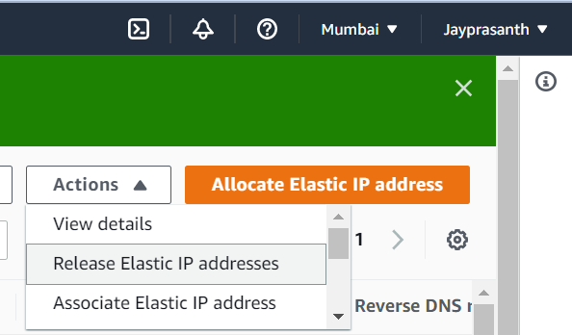

15.and release it

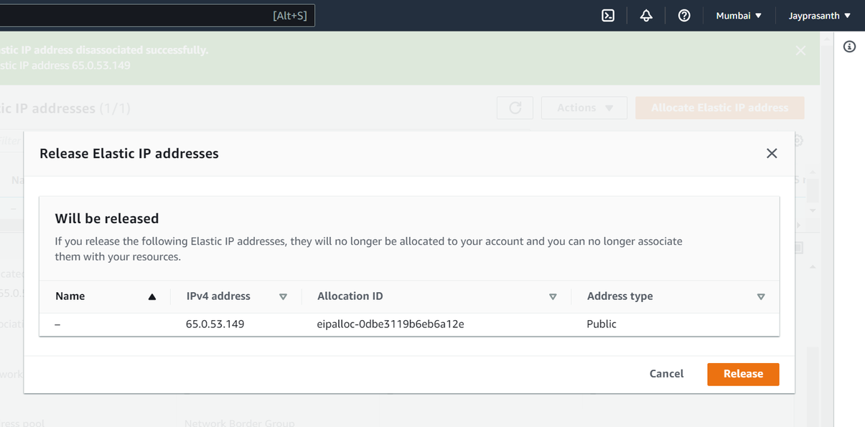

16. And delete our instance